Campaign plan
Campaign name | Campaign on increasing civic engagement in fiscal matters and improving budget literacy
Campaign objective | - Implement public awareness/communication measures on fiscal transparency, benefits of fiscal openness, fiscal response toward COVID-19 pandemic outbreak especially toward underprivileged social groups, its implementation status and financing.  - Organize Better Budget Dataquest to promote usage pf information provided through fiscal transparency digital platforms.
Campaign components | Series of measures and events to reach the objective of the campaign meeting needs of each target audience
Target audience | Social groups defined in audience definition section of this campaign plan
Key messages | Government taxing and spending policy has a direct effect on every citizen in various ways depending on which social group the citizen belongs to. Thus, it is crucial for every citizen to know about these effects and be able to know their rights and responsibilities.

- TARGET AUDIENCE
An effective public engagement process starts by having a clear idea of who we want to reach. As we cannot engage 100% of the population, a targeted approach will ensure that interested and impacted stakeholders are at the table throughout the process. Segments were defined based on survey conducted by MOF, and statistics of population by age group and number of internet users. Better Budget Data Quest will cover following social group
Table 1. Target group matrix
Segment name | Statistics | Approximate age bracket | Type of information the group may be interested | Channel to be used for reaching the group | Measures to be taken
High school students | 340,521 /2019/ | Under 18 | Definition of budget, fiscal process, general knowledge on tax and benefits of other payments to the government, such as social and health security payments | Social media and information board of schools | Pamphlet, poster using guerrilla technique shared on social media to advertise essay competition
University students | 332,930 /2019/ | 18-24 | Budget data availability and access, information on government measures taken to support students;  Internship opportunity at the MOF | Social media, Budget transparency website | Dataquest advertisement in forms of poster and video, preparation of Budget briefs (analysis on budget allocation, public expenditure and outcome of social sector programs );  Mentorship program
Researchers | 1.4 million | 24-54 | Budget data availability and access | Social media, Budget transparency website | Dataquest advertisement in forms of poster and video or preparation of Budget briefs (analysis on budget allocation, public expenditure and outcome of social sector programs )
Herders | 298,789 /2020/ | 18-55 | Information on government measures taken toward herders, and local budget | Governors of each aimag, FM radio | Audio and video advertisement
Disabled | 105,730 /2018/ | 16-55 | Information on government measures taken toward people with disabilities, elders and other marginalized groups in general and a fiscal response toward COVID-19 pandemic outbreak. | Khoroo management information board | Easy to understand pamphlet and poster meeting the needs of disabled
Stay-at-home mothers |  | 20-35 | Information on government measures taken toward mothers and children especially during COVID-19 pandimec outbreak. | Social media | Poster using guerrilla technique or video advertisement
Public officers | 198,463 /2019/ | 20-59 | Information on government measures taken toward public officers and a fiscal response toward COVID-19 pandemic outbreak. | Social media, MOF website  and GAP | Poster using guerrilla technique and short feature articles
Elders | 151,712 /2019/ | 60 and older | Information on government measures taken toward elders, social and health security benefits and a fiscal response toward COVID-19 pandemic outbreak. | Khoroo management information board | Infographic poster

Overall population of Mongolia is 3.3 million people as of 2019, out of which our target segments including high school students, university students, researchers take up to 58 percent.
Graph 1. Population of Mongolia as of 2019 (by age groups)
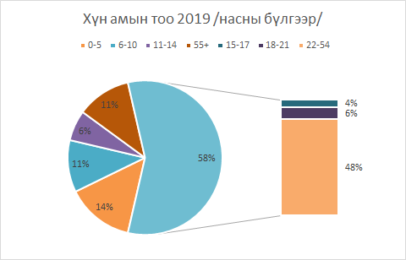
Ministry of Finance has conducted a survey on data providers, data users and controllers of the Glass Account Portal, in collaboration with Mongolian Economic Analysis and Research Center. 1403 adults participated in this survey, and 18% of participants responded that they know about Citizen’s Budget. Moreover, it was reported that 61.4% of participants do not know about Glass Account Portal in a “Survey among Glass Account Portal users” conducted by Open Society Forum in November 2018.
The result of these surveys shows that knowledge of the public on fiscal matters is low, and the MOF has faced a necessity to raise public awareness on budget in order to increase public oversight on budget management.
- MEDIA DISTRIBUTION CHANNELS
Current communication channels account for traditional media statements, the seldom use of social media, in most cases promoting official events or milestones in the budget cycle through Facebook and a relatively recent Twitter account which is scarcely used. Until 2020, The Citizen Budget was presented in a printed format which was distributed mainly to parliamentarians, and afterwards uploaded to the Ministry’s website, not fulfilling its objective of reaching the citizens. In recent years, following to the rapid digital transition in Mongolia, Citizen’s budget website was launched in February 2021, and the process of redevelopment of GAP has started.
According to “Glass account portal data providers, controllers and data users survey” 75.5% of participants were interested in obtaining information electronically via websites, Facebook, Twitter and other mobile applications (Please refer to appendix).

Digital communications allow us to reach in more cost-efficient way a broad population and even enables us to more effectively target different audiences according to their preferences. This presents itself as a new opportunity to communicate information that is useful for the public to know and understand fiscal information in an accessible and timely form. Mongolia has a medium-high internet penetration rate (61.0% as of June 2021), and of those, approximately two million people, 2.2 million use Facebook. Furthermore, the access to solar power has enabled digital communication with nomadic communities, through the use of technology, increasing the mobile use of social network by eleven percent from 2018 to 2019.
Graph 2. Essential headlines for digital adoption and growth as of January 2021
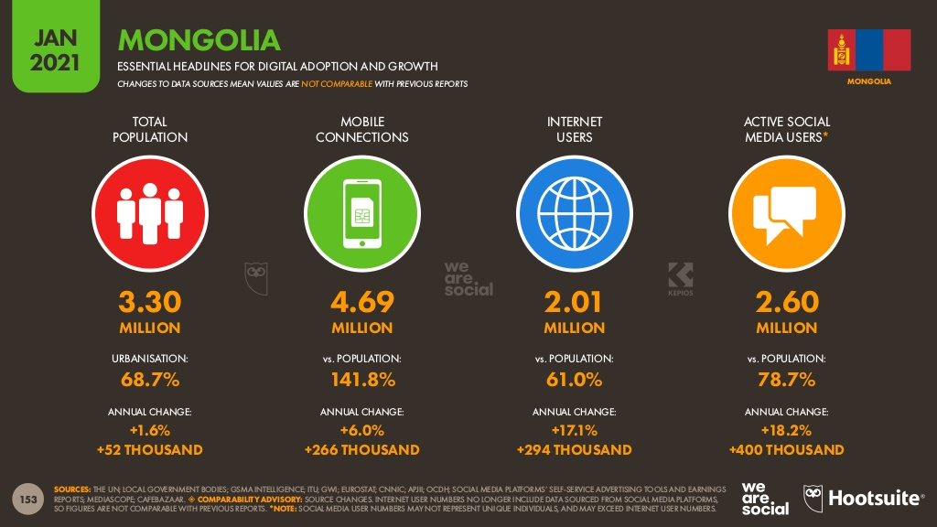
Source: https://datareportal.com/reports/digital-2021-mongolia
However, considering that facts that 39.0% of the population do not have Internet access and that communication can take many forms depending on the audience, this Strategy has chosen to utilize the following online and offline channels of communication:
Online Channels:
Social media, with emphasis on Facebook. Considering the aforementioned, the MoF will consistently use social media to communicate and engage with the users by providing information, but also by addressing user’s needs and feedback. Through social networks the MoF will disseminate information that invite the user to consult further disaggregation online. The CS Team will monitor the social media channels analytics constantly, in order to understand what message generates better engagement, and take these results into account in the design of future communications.
Online feedback form, which the MoF will have online on a permanent basis in the Glass Account Portal and Live Citizen’s budget website and will constantly monitor users' information needs, as well as suggestions for improving the Glass Account Portal and Citizen’s budget website and the information contained in both.
YouTube, it will be the social network destined to display explanatory contents on the topics of interest and usefulness for the users and will serve to address budget literacy projects that form part of the Strategy for Strengthening Fiscal Transparency and Public Engagement.
Offline Channels:
Promotional activities including participating in a television programs to introduce the recent achievements related to Citizen’s Budge, ongoing activities to improve the GAL and regulation and redevelopment of the GAP.
Posters, which will invite the different audiences to consult information disaggregated in online publications, based on information by areas of interest of citizens, identified in survey. These posters, according to the topic they address will be hanged in public spaces, such as schools, hospitals and government buildings. These posters can be part of the Citizen Budget dissemination, allowing to adapt the existing designs.
Guerrilla Marketing 2, developed in a playful way to generate citizen engagement in different areas of the budget. From general topics that seek citizen understanding in budgetary matters, to budget information on specific areas of the citizen interest.
To better understand Guerrilla Marketing, here are three hypothetical examples of implementation.
Image 1.Guerrilla general budget example, that could be implemented in main avenues
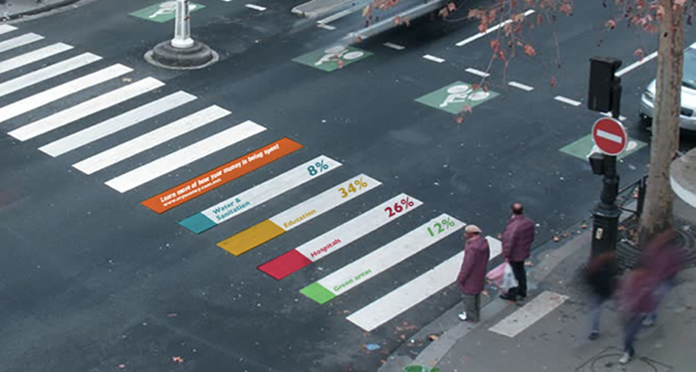

Source: Global Initiative for Fiscal Transparency
Image 2. Guerrilla branch budget example on education, that depending on the contents could be implemented outside universities.
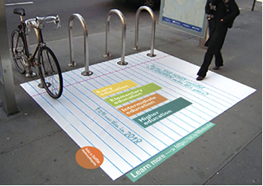
Source: Global Initiative for Fiscal Transparency
Image 3. Guerrilla specific budget topic example on pollution
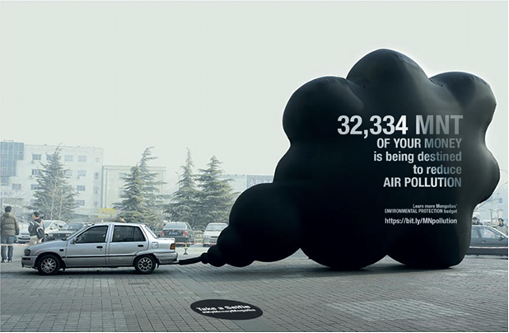
Source: Global Initiative for Fiscal Transparency
- CONTENT DEVELOPMENT
Following types of content may be developed based on identifying the needs of the three main target groups and other specified groups. Requirements for types of content are:
Type | Features | Creation and design
Photo | 93% of the most effective posts contain photos. Social media users pay high attention to quality and creativity of the photo. | Photos that do not have copyright issues should be used, or free photo galleries can be used.
Text | Text should be used at moderate rate. It is a good practice to keep number of characters under 250, best if kept under 80 characters. | Mongolian text should be typed using Cyrillic letter without any mistakes. Spellcheck.gov.mn website can be used for spellchecking.
Emoji | Emojis can be used for attracting attention of users but should not be overused. | Mostly can be typed in via computer, or use websites such as PiliApp, 😋 Get Emoji — All Emojis to ✂️ Copy and 📋 Paste 👌
Video | Short video content is a powerful tool to attract youth and convey information to them in a creative and capturing way. | Videos shot by camera can be used. Copyright issues should be checked beforehand in case of using videos produced by others.
Question | Compared to simple text, questions have more probability of receiving a response from viewers. | Questions can be raised in a poll format. It is favorable if question is created within 80 characters.
Infographic | Infographic is a collection of images, charts, and minimal texts that gives an easy-to-understand overview of topic. As infographic use striking, engaging visuals to communicate information quickly and clearly, this type of content is on the rise lately. | Easy to understand format, using moderate amount of text
Animation | Animated videos receive high number of views on social medias.

- ACTION PLAN
Following actions should be taken for a successful implementation of the campaign:
Action description | Parties responsible | Target audience | Delivered by | Key message | Cost | Outcome/ Deliverable
Video and article of the Minister of Finance on fiscal transparency | Consulting firm, MOF | All target groups previously defined | Late-August | Video and article conveys the Ministers position on fiscal transparency, its importance and calling the public to actively participate in upcoming events | TBD, including video creation and article writing cost, as well as advertisement cost through television and newspaper. | A short video of up to 2 minutes,  interview styled article, (can be divided into  2-3 interviews)
Short videos and article on promoting amendments to the GAL and regulation | Consulting firm, MOF | Public | August-December | Video conveys the ongoing improvement related to the GAP, expected amendments to the GAL and regulation, inform how public can participate and include their opinion to the draft amendments of the law and regulation. | TBD,  including video creation and article writing cost, as well as advertisement cost through television and newspaper. | A short video of up to 2 minutes,  interview styled article, (can be divided into  2-3 interviews)
Better Budget Dataquest | Consulting firm, MOF | University students | September-October, 2021 | Through this activity innovative digital and technological solutions related to budget data usage for the young adults (individuals in their teens and early twenties); prospective researchers will be identified. | Organizing cost, award prize cost / USD 8000/ | Materials submitted by participating teams on use of the open data.  Short video introducing the CB website, its navigation, particularly open data menu, showing how the data can be obtained from the platform.
 |  | Researchers
Research conference | Consulting firm, MOF | University students and researchers | September-October, 2021 | Promote budget data usage | Award prize cost /2500/ | Materials submitted by participating researchers. Content, poster and materials used for the promotion.
Essay competition | Consulting firm, MOF | high school students | September-December, 2021 | Strengthen high school student’s knowledge on budget related matters | award prize cost /500/ | 3 essays
Internship/Mentorship program | Consulting firm, MOF | University students | September-December, 2021 | Provide opportunity to students to have an experience of daily work at the MOF in different departments | award prize cost /2850/ | Brief report from the participants
Promotion of budget related information and fiscal response to COVID-19 to the different social segments | Consulting firm, MOF | Middle school pupils | September-December, 2021 | Introduce the importance of budget, social and health security fund through which Government takes care of youth and children. | TBD | Content, poster and materials used for the promotion
 |  | Stay-at-home mothers/fathers |  | Improve understanding of public services available to mothers/fathers and their children | TBD
 |  | Herders |  | Improve understanding of public services available to herders | TBD
 |  | Disabled |  | Improve understanding of public services available to disabled and their caregivers | TBD
 |  | Public officers |  | Improve understanding of public services available to public officers and their family | TBD
 |  | Elders |  | Improve understanding of public services available to elders and their caregivers | TBD

Campaign tracking and reporting
The consulting firm will directly report to the Head of the Budget Consolidation Division of the Fiscal Policy and Planning Department, and Head of the Treasury Department of MOF.
Appendix
In 2020 MOF conducted a survey from data providers, controllers and data users of Glass Account Portal in collaboration with Mongolian Economic Analysis and Research Center. The survey included questions on the type of fiscal data citizens are interested in, their preferred media channel and data format. Based on the survey specific strategy to deliver data and information to the public was developed.
The following table presents that the most interested formats and channels to access/receive information is ranked by subject.
Table 2. Types of formats and channels to access/receive information /data users/
№ | Format | Channel
1 | Open data format | Facebook
2 | Video | Website
3 | Poster and brochure | Mobile application
4 | Book and booklet | TV
5 |  | GAP
Source: Report of data providers, data users and controllers survey (2020)
According to the Report of data providers, data users and controllers survey (2020) conducted by Mongolian Economic Analysis and Research Center, over 80% of public officers access to budget related data through MOF website, and 43% through Glass Account Portal. Main media channels popular among citizens are:
Figure 1. Preferred media channel among citizens

Source: Report of data providers, data users and controllers survey (2020)

Citizens were most interested in the following budget related materials and information:
Figure 2. Types of information and topics citizens are the most interested in (number of people)

Source: Report of data providers, data users and controllers survey (2020)
Table 2. Cell phone usage survey among different age groups of men (percent within the group)

Source: Source: Report of data providers, data users and controllers survey (2020)
Table 3. Internet usage survey among different age groups of men (percent within the group)

Source: Report of data providers, data users and controllers survey (2020)

